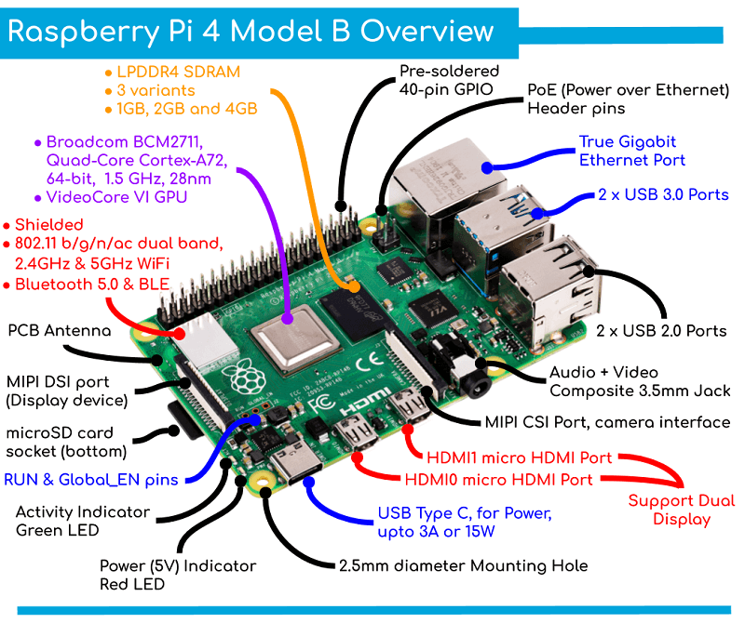

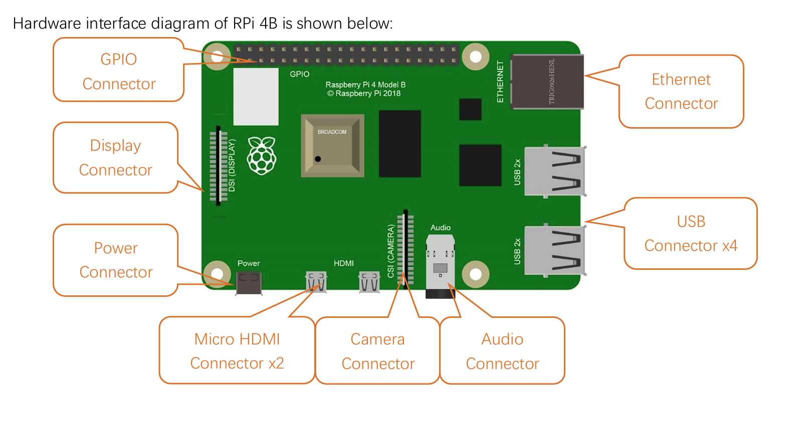

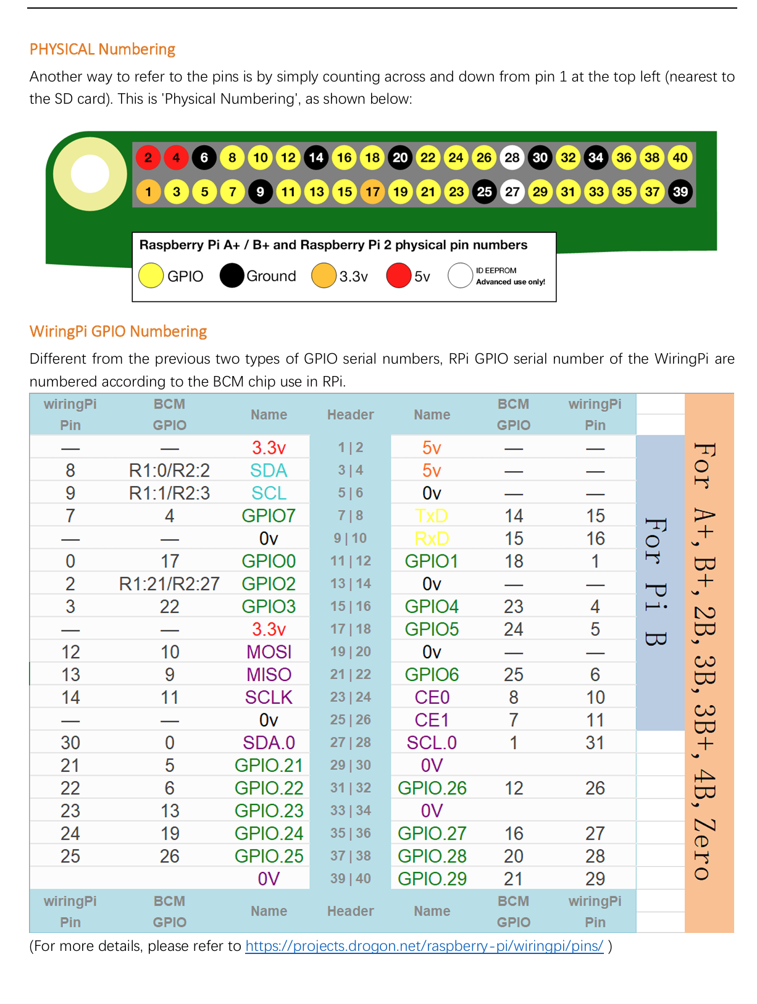

Let’s use a **simple example** to explain how **SCL** (clock) and **SDA** (data) work together.

**Imagine a Classroom with a Teacher (Master) and Students (Slaves):**

* **Teacher (Master)**: The teacher controls the classroom and gives instructions to the students.
* **Students (Slaves)**: The students follow the teacher’s instructions.

Now, let’s connect this to **SCL and SDA**:

1. **Teacher claps (SCL - Clock)**: Every time the teacher claps their hands, it’s a signal for the students to either give an answer (send data) or listen for the next instruction (receive data). This clap is like the **clock signal (SCL)** that keeps everyone synchronized.
2. **Students answer or receive data (SDA - Data)**: Every time the teacher claps, the students either **say a word (send data)** or **listen (receive data)**. This action corresponds to the **data (SDA)** being sent or received.

**Step-by-step Example:**

* The teacher says, "When I clap my hands, give me your answer one word at a time."
* The teacher claps **(SCL)**.
* A student says, "I" **(SDA – 1st bit)**.
* The teacher claps again **(SCL)**.
* The student says, "am" **(SDA – 2nd bit)**.
* The teacher claps again **(SCL)**.
* The student says, "ready" **(SDA – 3rd bit)**.

This continues until the entire message has been exchanged, with the teacher clapping at regular intervals to control when the student speaks.

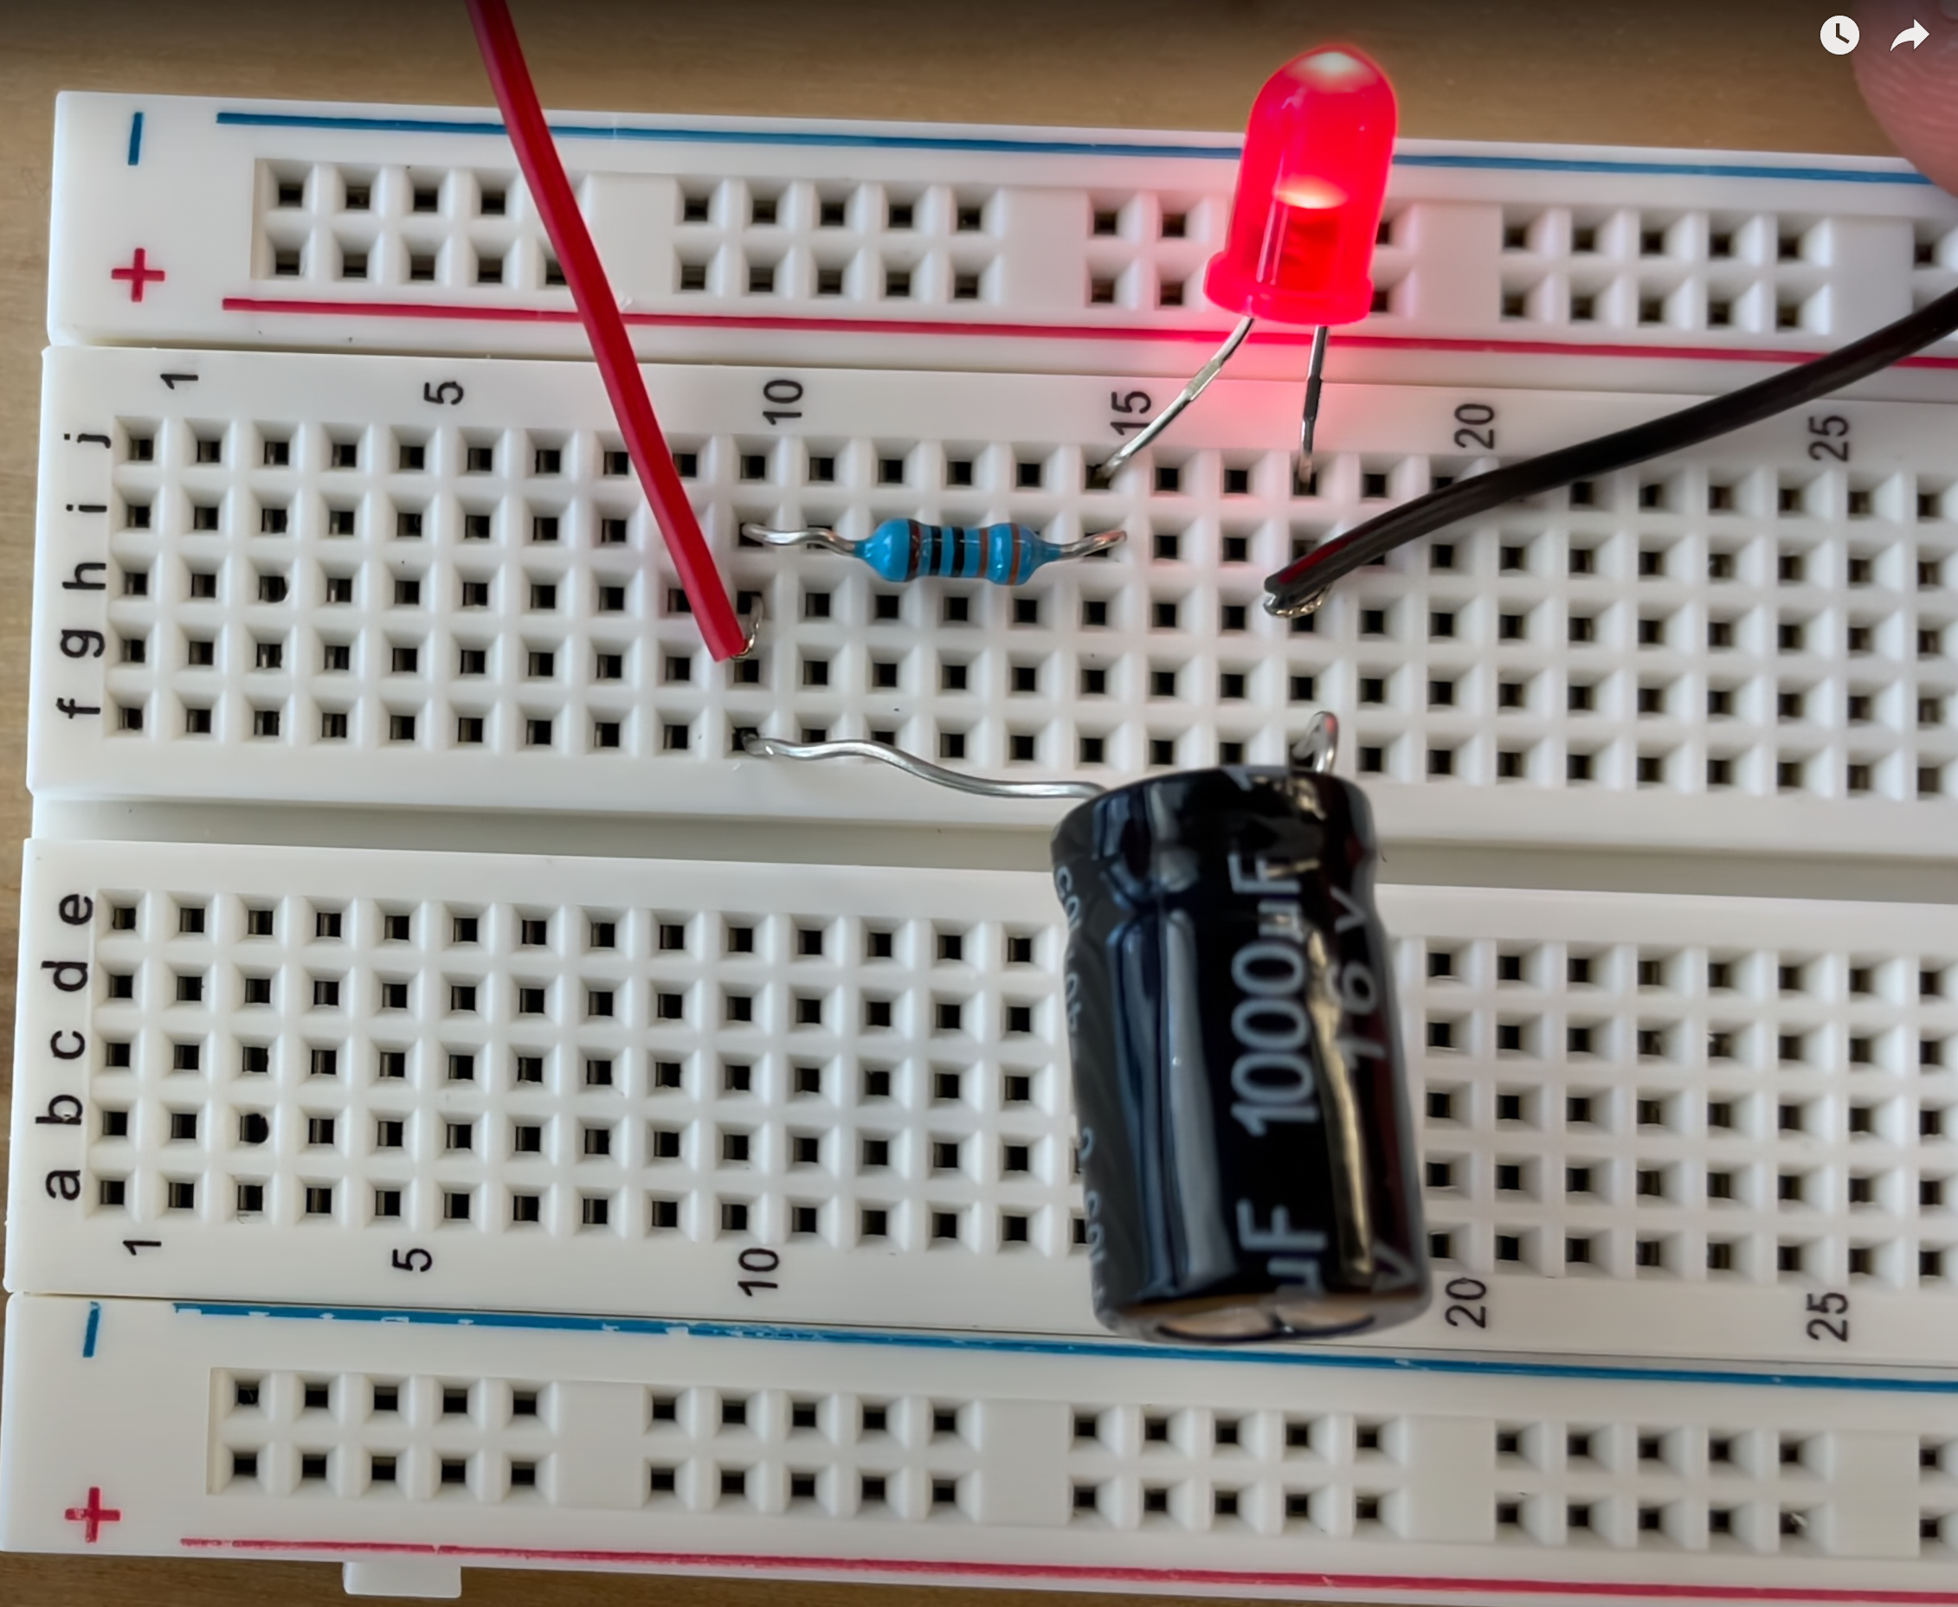

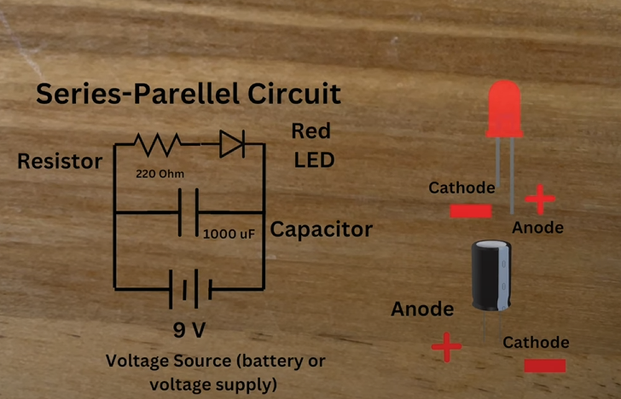

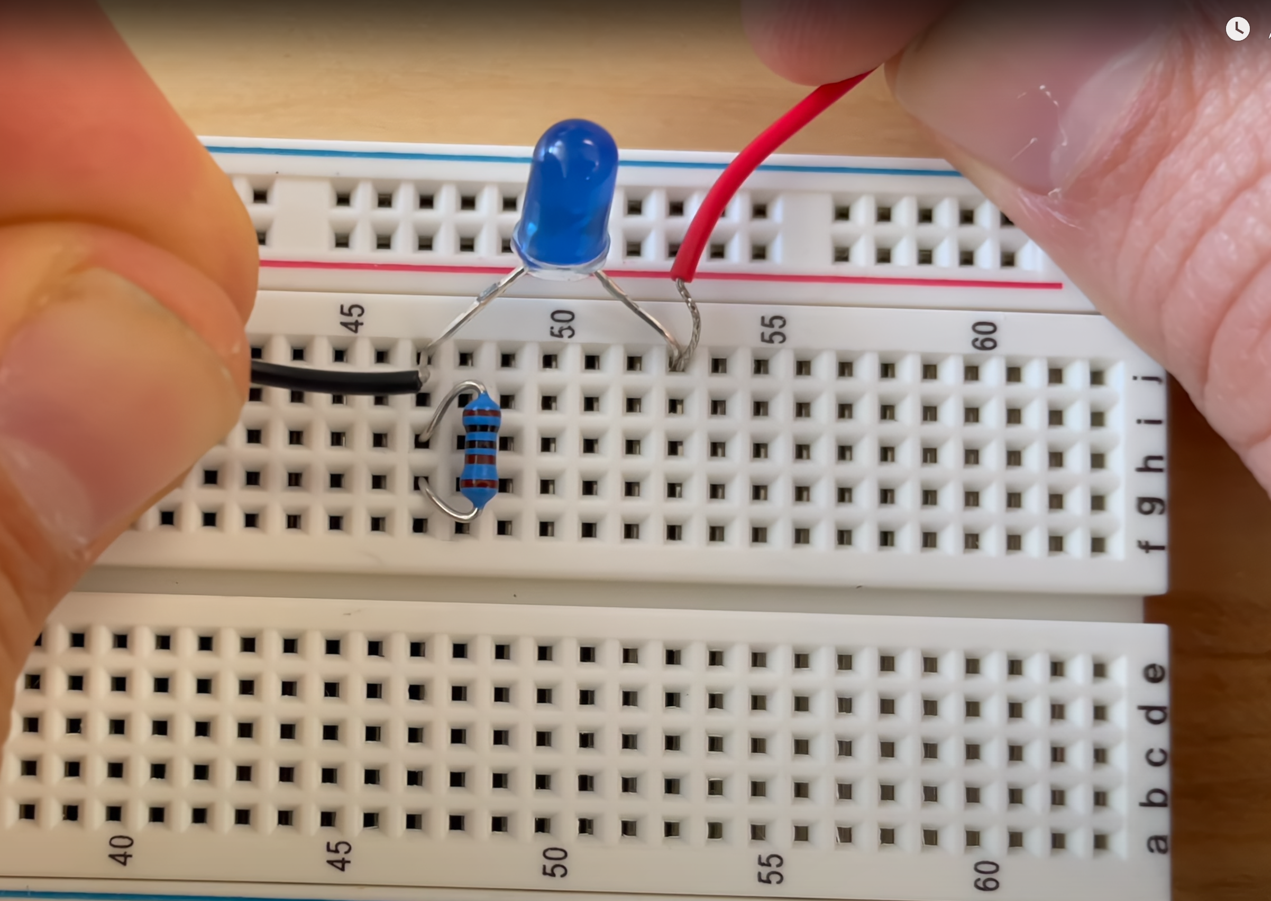

Short circuit!!!

Resistor got short and too much power gets transferred to LED!LED burns!

